SSL Handshake
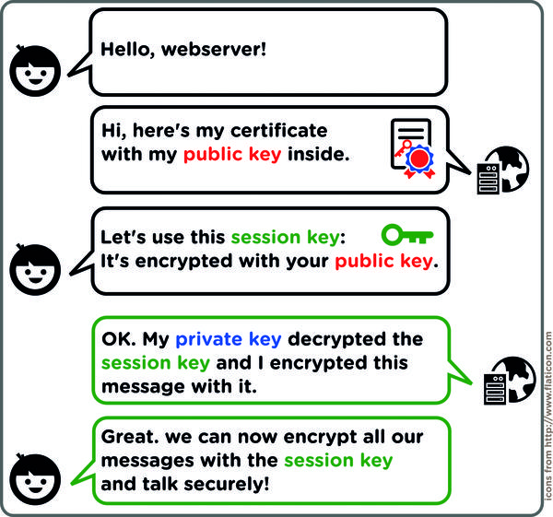
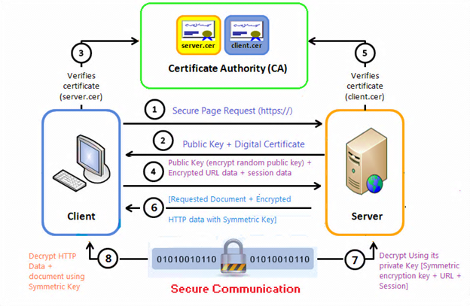
SSL/TLS Client and Server example
In this exercise we will build a Java Socket program where a socket client establishes an SSL connection with a socket server and then sends a word to the server. The server reverses the word and sends it back to the client. The program needs a set of keys which are generated in Java using the keytool and also needs a keyStore (on the server side) and a trustStore (on the client side)
The main difference between trustStore vs keyStore is that trustStore (as name suggest) is used to store certificates from trusted Certificate authorities (CA) which are used to verify certificate presented by Server in SSL Connection while keyStore is used to store private key and own identity certificate which program should present to other parties (Server or client) to verify its identity.
Anytime a client will connect to the server, server will present its certificate stored in KeyStore and client will verify that certificate by comparing with certificates stored on its trustStore.
Read more: http://www.java67.com/2012/12/difference-between-truststore-vs.html#ixzz5dhkEUAQf
- Create a new folder called ssl
- Create a public/private key pair and store them in a keystore as follows:
keytool -genkeypair -v -keystore herong.jks -alias JKS (or keytool -genkeypair -keyalg DSA -v -keystore herong.jks -alias JKS)
Note the keystore file is called herong.jks
Note you must give details and choose a password for the keystore
- Copy the SslReverseEchoer.java file to your folder from the X drive
- Add your keystore password to the file where it says password
- Compile the file and run it. Review the code
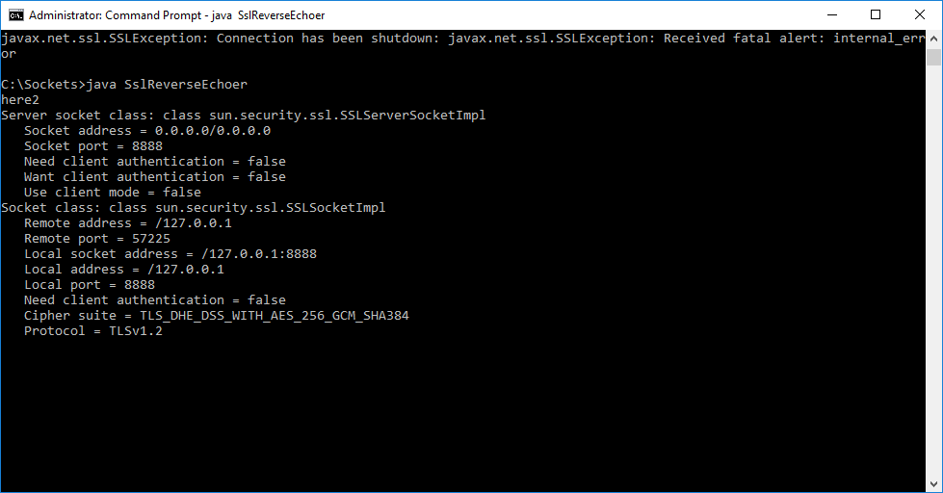
- Create a folder in the ssl folder called client
- Copy and paste SslSocketClient.java to the client folder and compile it. Review the SslSocketClient code.
- You must make a trust store on the client to hold the keys. To create the trust store we will takes the keys from the server and put them in a certificate. We will then use this certificate to create a trust store on the client.
- To get the certificate, in the server folder run
keytool -exportcert -alias JKS -file my_home.crt -keystore herong.jks -storepass password

Certificate stored in file <my_home.crt>
A certificate contains the public part of the key.
The certificate, in addition to containing the public part of the key, contains additional information such as issuer, what the certificate is supposed to be used for, and other types of metadata.
Typically, a certificate is itself signed with a private key that verifies its authenticity.

- Now copy the certificate (my_home.crt) to the client folder and in the client folder create a store and put the certificate keys in the store
keytool.exe -importcert -alias herong_home -file my_home.crt -keystore public.jks -storepass password
10. Now run SslReverseEchoer.java again (if it stopped). Then run SslSocketClient with public.jks as a trustStore.
java -cp . -Djavax.net.ssl.trustStore=public.jks -Djavax.net.ssl.trustStorePassword=password SslSocketClient

If you have errors add the following to both server command
"-Djdk.tls.server.protocols=TLSv1.2" and "-Djdk.tls.client.protocols=TLSv1.2" to client command
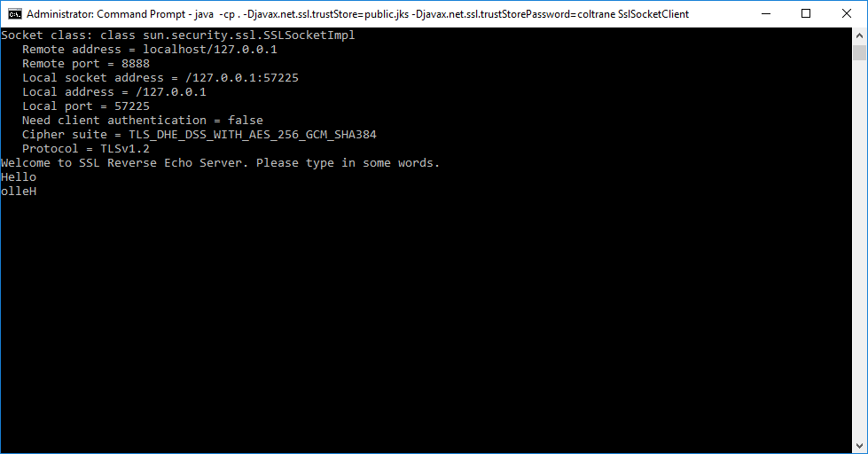
- You can view the SSL handshake as described in the webcast with -Djavax.net.debug=all

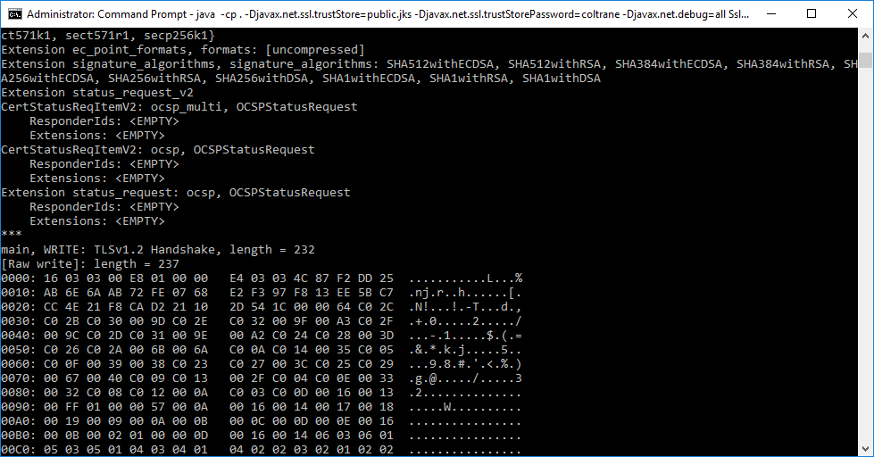
And note the data is encrypted (I send the word “john”)
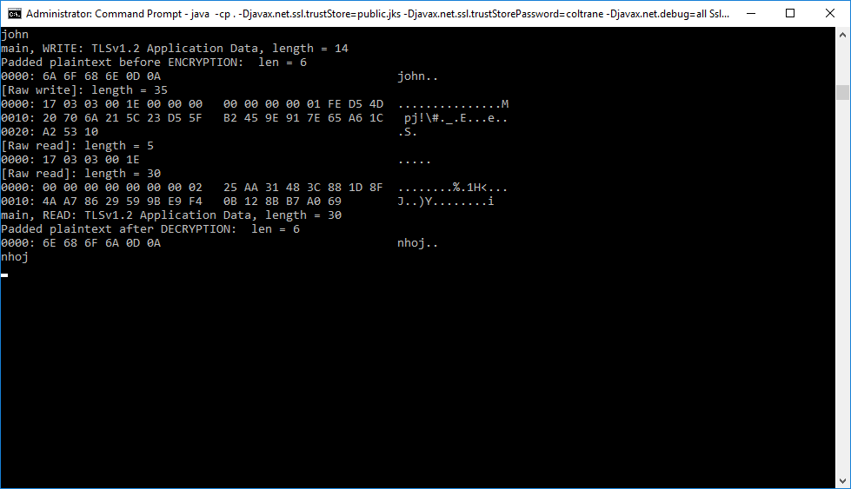
If you download and install Wireshark you can drill into the protocol messages. Choose the Adapter for loopback traffic capture and set the filter to ssl. You can then drill into the protocol messages
